Let's start by analyzing the data in the provided CSV file and then create a dashboard with various graphs and diagrams. I'll load and examine the data first to understand its structure and contents.

I'll load the CSV file now. This might take a moment.

The dataset contains 18,637 entries with the following columns:

1. `Unnamed: 0`: Index column

2. `Game ID`: Unique identifier for each game

3. `White Rating`: Rating of the white player

4. `Black Rating`: Rating of the black player

5. `Opening ECO`: ECO code of the opening used

6. `Opening Ply`: Number of half-moves in the opening

7. `White Centi-pawn Loss`: Centi-pawn loss for the white player

8. `White's Number of Inaccuracies`: Number of inaccuracies made by the white player

9. `White's Number of Mistakes`: Number of mistakes made by the white player

10. `White's Number of Blunders`: Number of blunders made by the white player

11. `Black Centi-pawn Loss`: Centi-pawn loss for the black player

12. `Black's Number of Inaccuracies`: Number of inaccuracies made by the black player

13. `Black's Number of Mistakes`: Number of mistakes made by the black player

14. `Black's Number of Blunders`: Number of blunders made by the black player

Next, I will create a dashboard with various visualizations including the following:

1. Distribution of player ratings (White and Black)

2. Most common openings (ECO codes)

3. Distribution of inaccuracies, mistakes, and blunders for both White and Black

4. Relationship between player ratings and centi-pawn loss

Let's start by creating these visualizations. This might take some time.

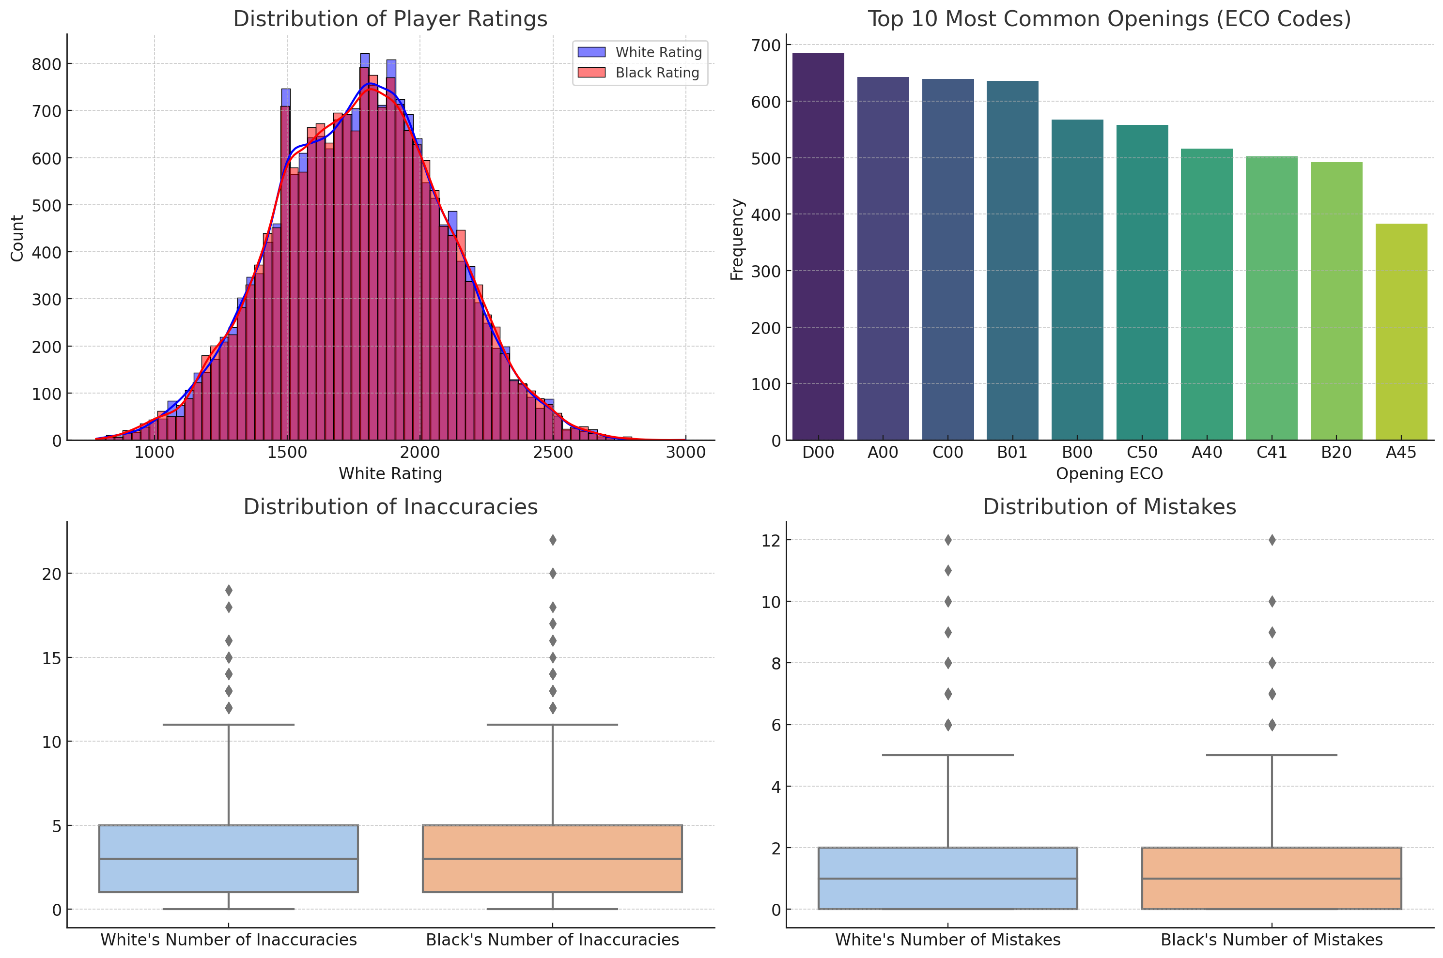

The dashboard includes the following visualizations:

1. \*\*Distribution of Player Ratings (White and Black):\*\* Both distributions show a range of player ratings, with white and black players having similar rating distributions.

2. \*\*Top 10 Most Common Openings (ECO Codes):\*\* The bar plot highlights the most frequently used openings in the dataset.

3. \*\*Distribution of Inaccuracies:\*\* Boxplots for inaccuracies made by white and black players.

4. \*\*Distribution of Mistakes:\*\* Boxplots for mistakes made by white and black players.

Next, I'll create additional visualizations for the distribution of blunders and the relationship between player ratings and centi-pawn loss.

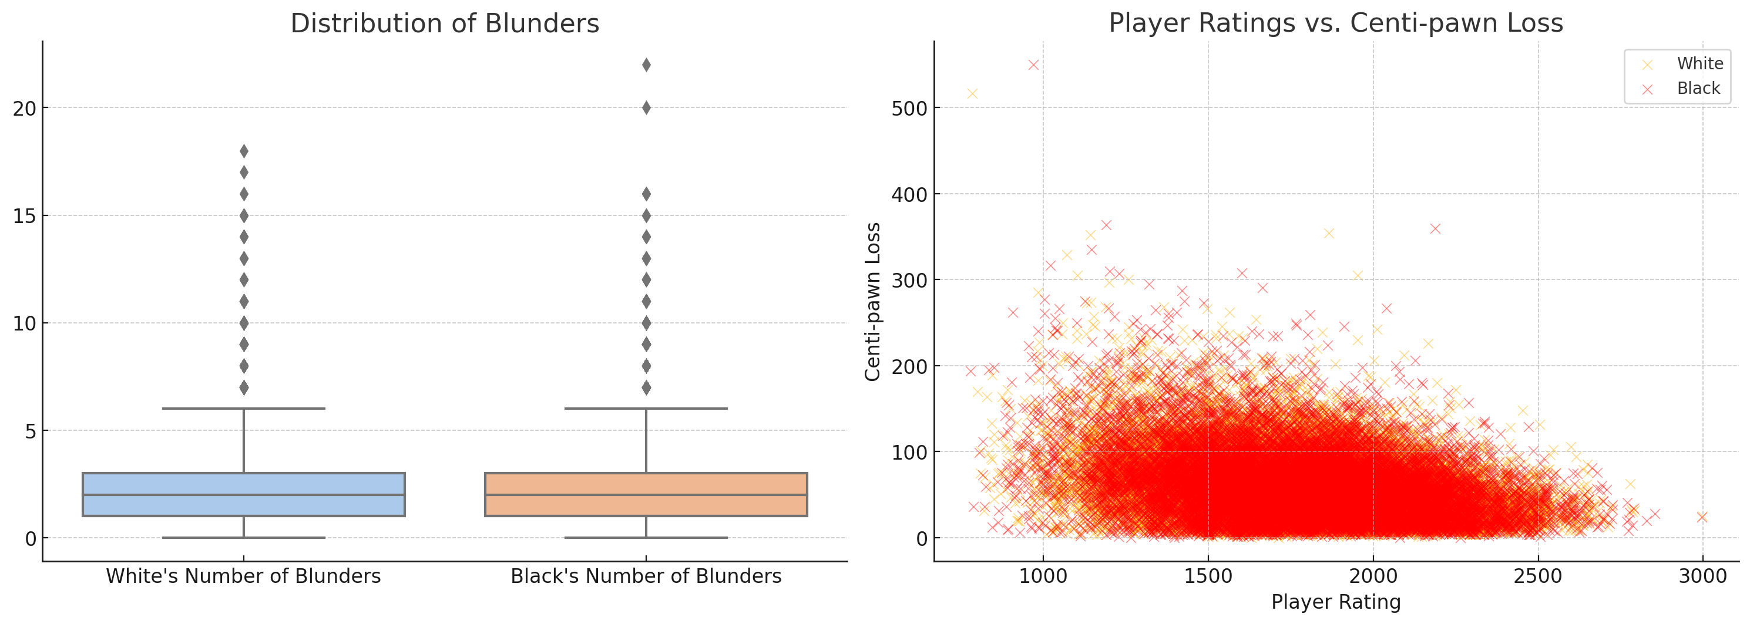

The additional visualizations include:

1. \*\*Distribution of Blunders:\*\* Boxplots for blunders made by white and black players.

2. \*\*Player Ratings vs. Centi-pawn Loss:\*\* Scatter plot showing the relationship between player ratings and centi-pawn loss for both white and black players. It indicates how centi-pawn loss varies with player ratings.

Would you like to further customize any of these visualizations or add new ones?